BFS – Breadth-First Search

Assumption: all edges have unit cost.

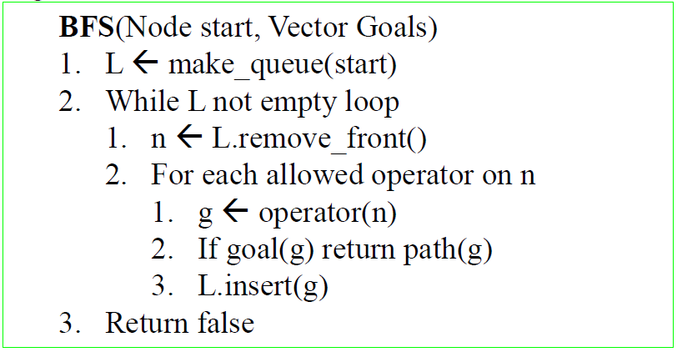

DFID - Iterative deepening depth-first search

Recursive DFID with loop avoidance.

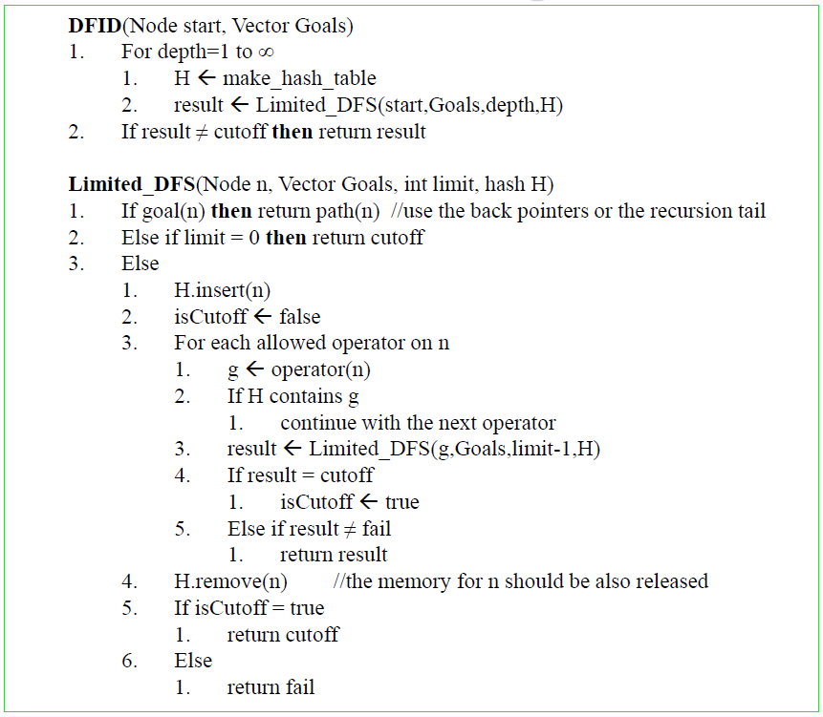

A\*

Uniform Cost Search, with Heuristic function (Manhattan distance)

F(n) = G(n) + H(n)

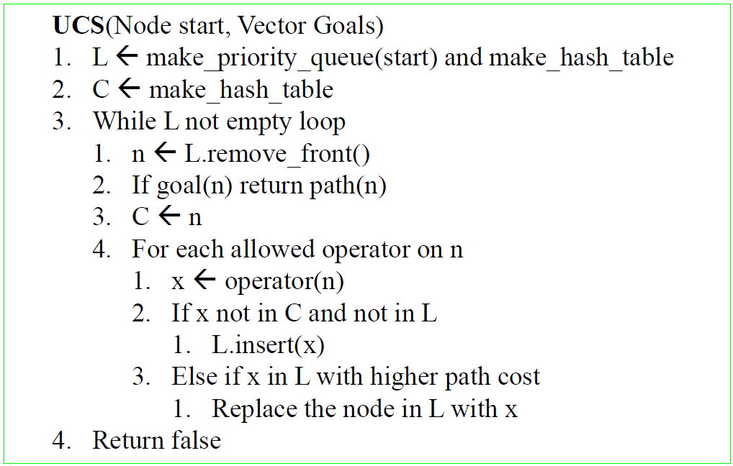

IDA\* - Iterative Deepening A\*

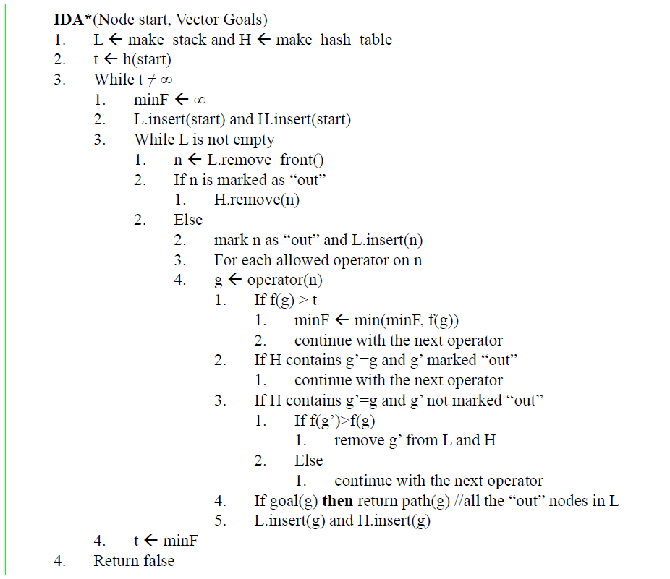

DFBnB - Depth First Branch and Bound

